
No. 9
—

2025

NEMA - Annual General Meeting (AGM)
26th October 2026


(
Please turn to page 9 for further details).

NEMA OFFICE CLOSURES
- Please note, the NEMA office will be closed on Tuesday, 6 October 2026 as staff will be attending a workshop.
- Please note, the NEMA office will be closed on Wednesday, 21 October 2026 as staff will be celebrating Seniors Month with our community.
We apologise for any inconvenience these closures may cause and thank you for your understanding.
OCTOBER MID-WEEK BREAK CANCELLED
There will be no Mid-Week Break at the NEMA office this month due to our Seniors Month Luncheon celebration. We look forward to celebrating together with our community!
A NEW CHAPTER FOR MULTICUTURAL AND MULTIFAITH VICTORIA
We are pleased to share an important milestone for Victoria’s multicultural and multifaith communities.
The Multicultural Victoria Amendment (Multicultural and Multifaith Victoria) Bill 2026 has now passed Parliament.
From 1 October 2026, the Victorian Multicultural Commission and Multicultural Affairs will come together as a new independent entity, Multicultural and Multifaith Victoria.
This is an important development in the way the Victorian Government works with and supports multicultural and multifaith communities across the state. It recognises the valuable social, cultural and economic contributions that people from diverse backgrounds make to Victoria every day.
As Victoria enters this new chapter, it is an opportunity to reflect on the strength, resilience and diversity of our communities and continue working together to build a more inclusive and connected Victoria.
For more information, visit the Victorian Multicultural Commission website:
Multicultural and Multifaith Victoria | vic.gov.au

2026 CULTURAL DINNERS
6.00pm—8.00pm (The 3rd Wednesday of the month) New Location: Purbrick Hall
For Bookings Contact: Pangerang Community Hub on 0357 213813 or NEMA on 0477 995 306
COST: $15 PER PERSON - BOOKINGS ESSENTIAL AS PLACES ARE LIMITED 21st October - Japan

18th November - Australia - Aussie BBQ

DAYLIGHT SAVINGS 2026
In Victoria, daylight saving time for 2026/2027 begins on Sunday, October 4, 2026 and ends on Sunday, April 4, 2027.
Start: Move your clocks forward one hour at 2:00 AM AEST to 3:00 AM AEDT on Sunday, October 4, 2026.
CITIZENSHIP CEREMONY WANGARATTA
On 17 September, NEMA was delighted to join the Rural
City of Wangaratta community in celebrating Australian Citizenship Day and welcoming 11 new Australian citizens from India, Latvia, Nepal, the Philippines and Vietnam.
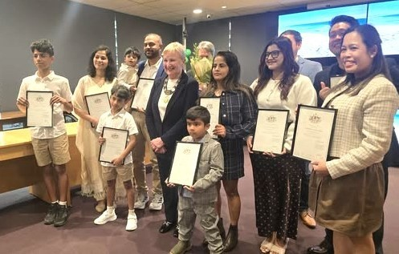
At NEMA, we proudly support people from diverse backgrounds as they settle, connect and build a sense of belonging in our community. Moments like this remind us of the many cultures, stories and journeys that contribute to the vibrant and diverse community we call home. A very warm welcome to our newest Australians! We’re so pleased to have you as part of the Wangaratta community.
WATER SAFETY PROGRAM—REGISTRATION NOW OPEN!
NEMA is excited to offer a Water Safety Program for multicultural communities, delivered in collaboration with Wangaratta Sports and Aquatic Centre (WSAC) and Sport North East.

The program is designed to help children and adults build basic swimming and water safety skills in a supportive and inclusive environment.

- Program starts: Week commencing Monday, 19 October 2026
- Location: Wangaratta Sports & Aquatic Centre
- After-work weekday sessions and weekend morning sessions available
- Open to kids and adults of all ages
- Women-only sessions can be arranged if required
- FREE program – a refundable $50 deposit is required and will be refunded if you attend at least 75% of classes.
Registrations close Monday, 12 October 2026 to allow time for session planning and participant grouping.
Spaces are limited, so we encourage interested community members to register early! • 03-5721-5490 or 0477 995 306
faryal@nema.org.au
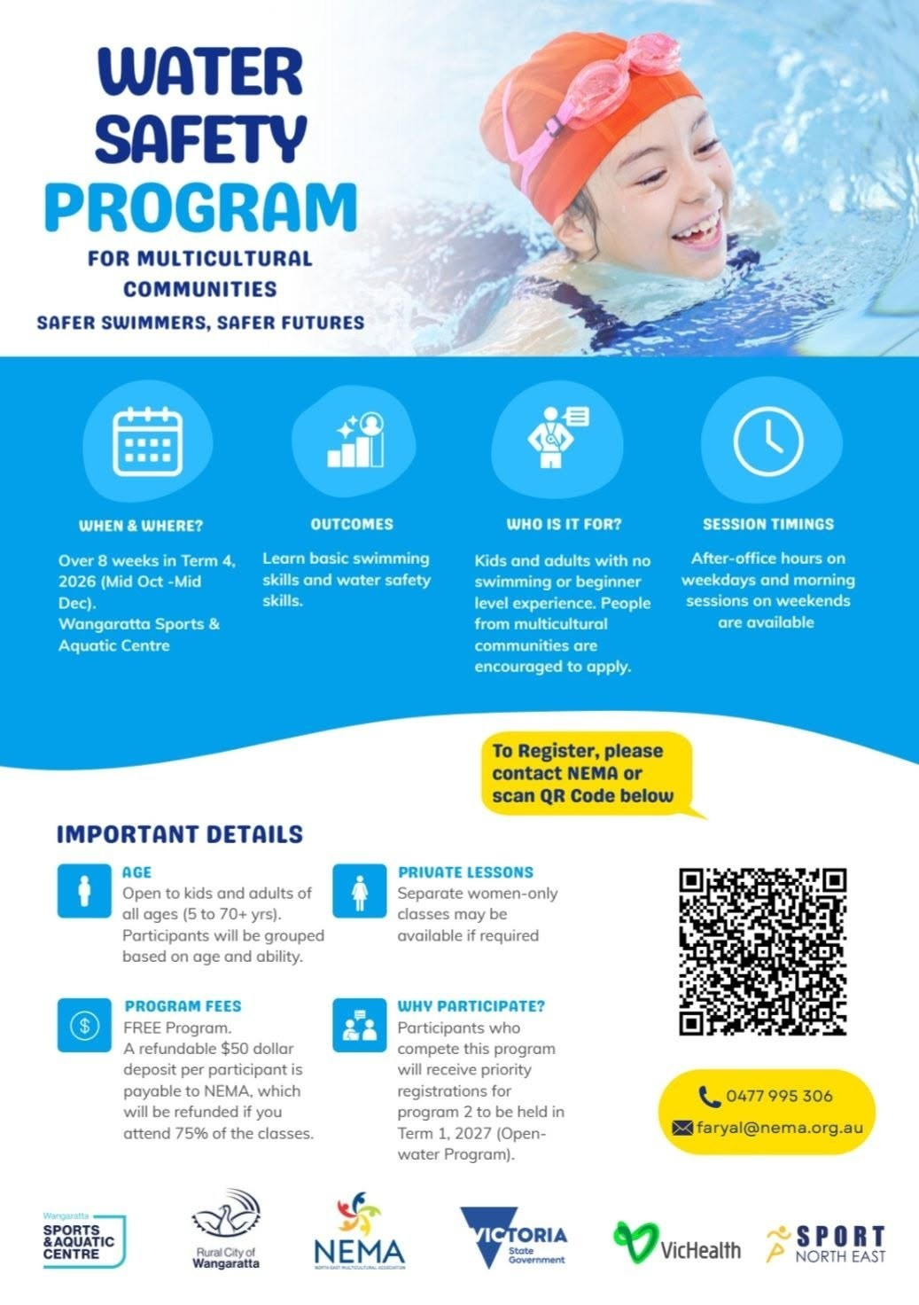
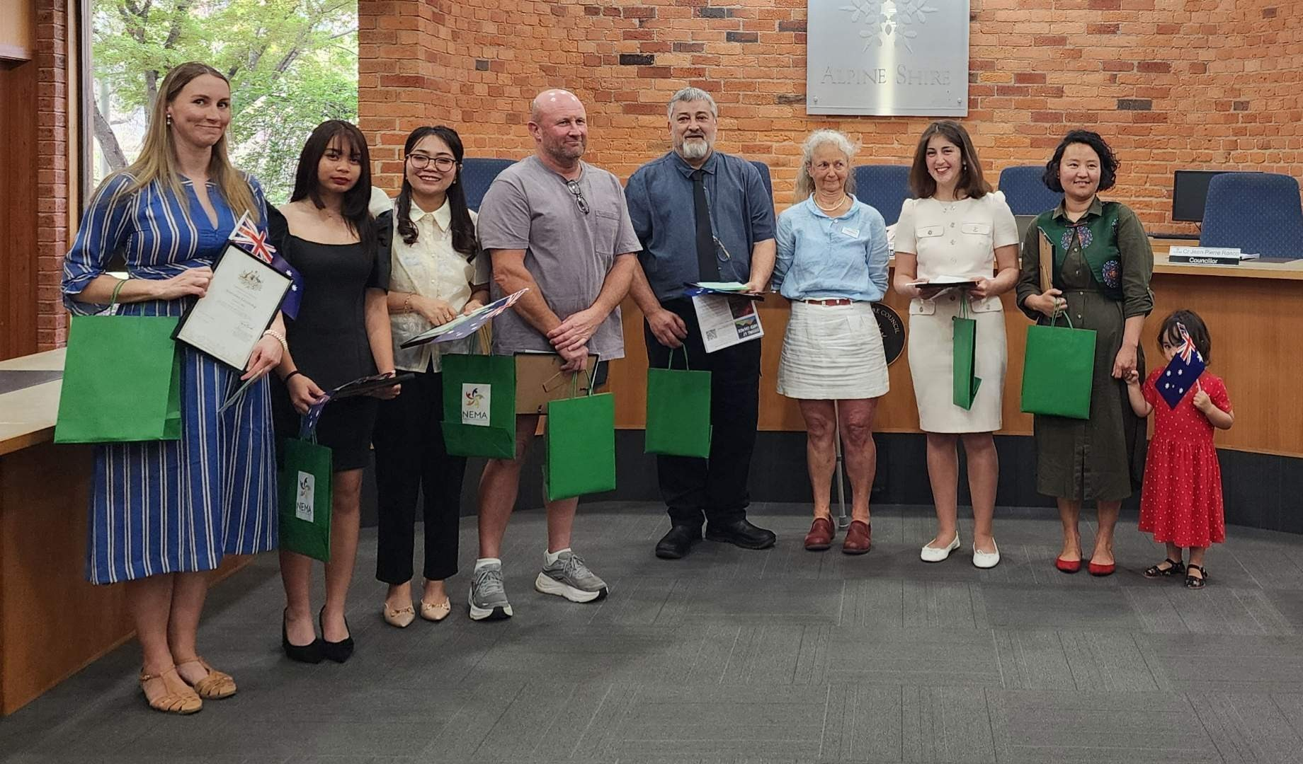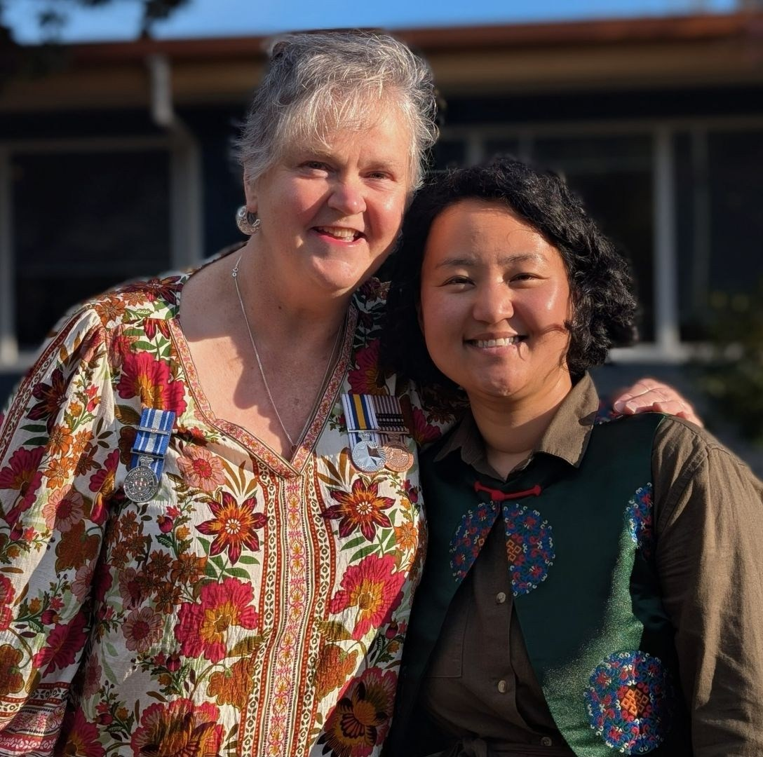

CITIZENSHIP CEREMONY ALPINE SHIRE

NEMA is proud to celebrate the diversity, cultures and life experiences that enrich our communities. We
warmly welcome our newest citizens from Germany, Mongolia, New Zealand, the Philippines and Serbia,
and wish them every happiness as they continue to call Alpine Shire home.

A special thank you to Jenenne Stiles, NEMA Cultural Advocate, for attending the citizenship ceremony on
behalf of NEMA and representing our commitment to welcoming, connecting and supporting our
multicultural community.

Congratulations to all our new citizens!

SENIORS MONTH LUNCHEON
We look forward to welcoming everyone who has booked for our Seniors Month Luncheon.
Date: Wednesday, 21st October 2026 Time: 12:00pm–2:00pm Venue: RSL Wangaratta, 2–4 Templeton St, Wangaratta VIC 3677 A few important reminders for booked guests:
This event is for registered guests only, unfortunately we cannot accommodate any additional guests who have not booked.
As the RSL is a registered club, everyone will need to complete the sign-in process at the entrance upon arriving.
Please also note that guests who live within 10km of the club will need either to become an RSL member or be signed in as a guest of a member who is attending on the day.
GRIT AND RESLIENCE FESTIVAL

Saturday, 10 October 2026 4:00pm–6:30pm King George Gardens, Wangaratta
NEMA is excited to be part of the Organisational Consortium and will be hosting a community stall at this wonderful festival. We invite everyone in the community to come along and enjoy this free familyfriendly event with lots of activities, entertainment and food for everyone to enjoy.
Wet weather location: If the event needs to be relocated due to rain it will be held at St Patrick’s Hall, 1A Ford Street, Wangaratta.
Come along, say hello to the NEMA team and enjoy an afternoon of fun, food and community connection.
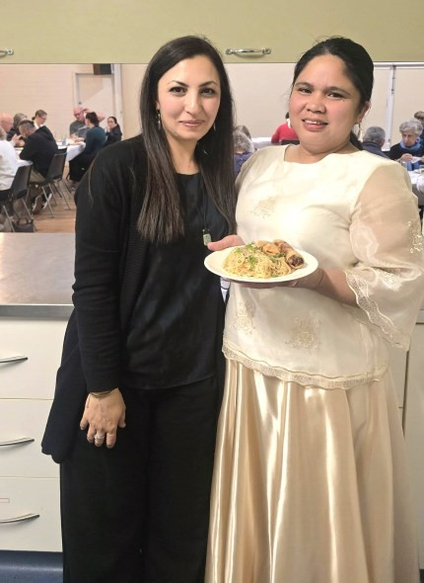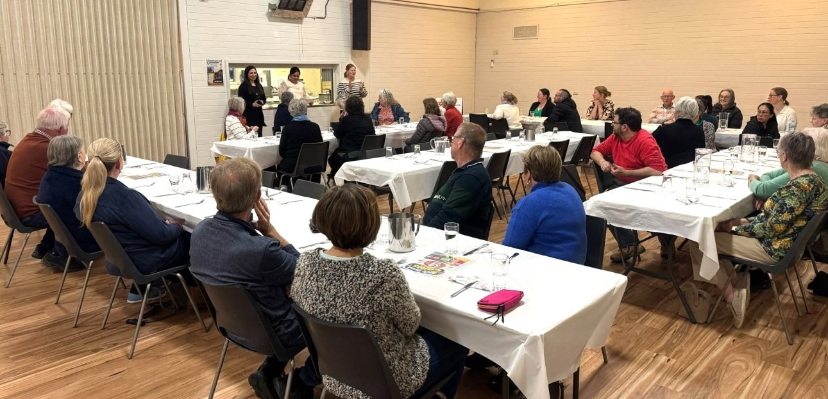

CULTURAL DINNER
—
THE PHILIPPINES

A big thank you to our Filipino Cultural Ambassador, Kristine Bareja Lovel for preparing and sharing a
beautiful meal at last night
’
s cultural dinner. Your time, effort and generosity are truly appreciated. A
wonderful evening of Filipino food and community!

Below left: Faryal Khan with Philippine host: Kristine Bareja Lovel

.

A LOVELY DAY WITH OUR ALPINE SOCIAL GROUP

Our Alpine Social Group came together for a wonderful lunch at the Red Stag Deer Farm in Myrtleford. The day was spent enjoying good food, beautiful spring weather and each others company. It is always wonderful to see our social group growing, bringing people together, creating connections, friendships and a strong sense of community. Thank you to everyone who joined us and helped make the day so special. We look forward to many more gatherings together. New members are always welcome.
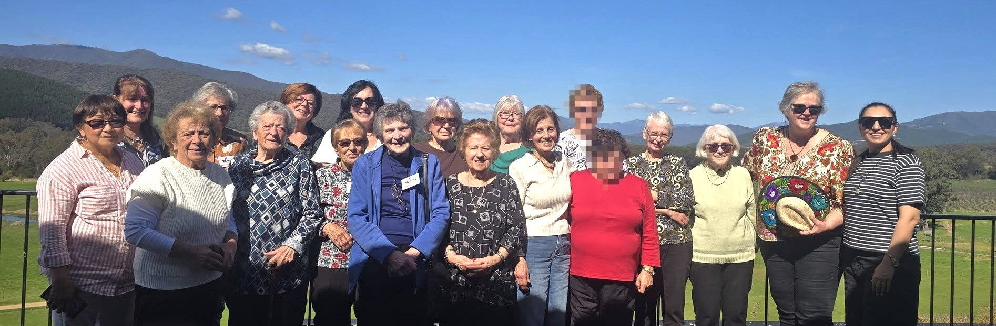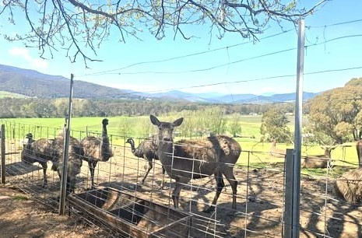

Beep Beep!!

Congratulations to Niti
Sharma on the passing of
her driver
’
s licence test!

Wishing you safe and
happy motoring from
everyone at NEMA.

Red Stag Deer Farm, Myrtleford.

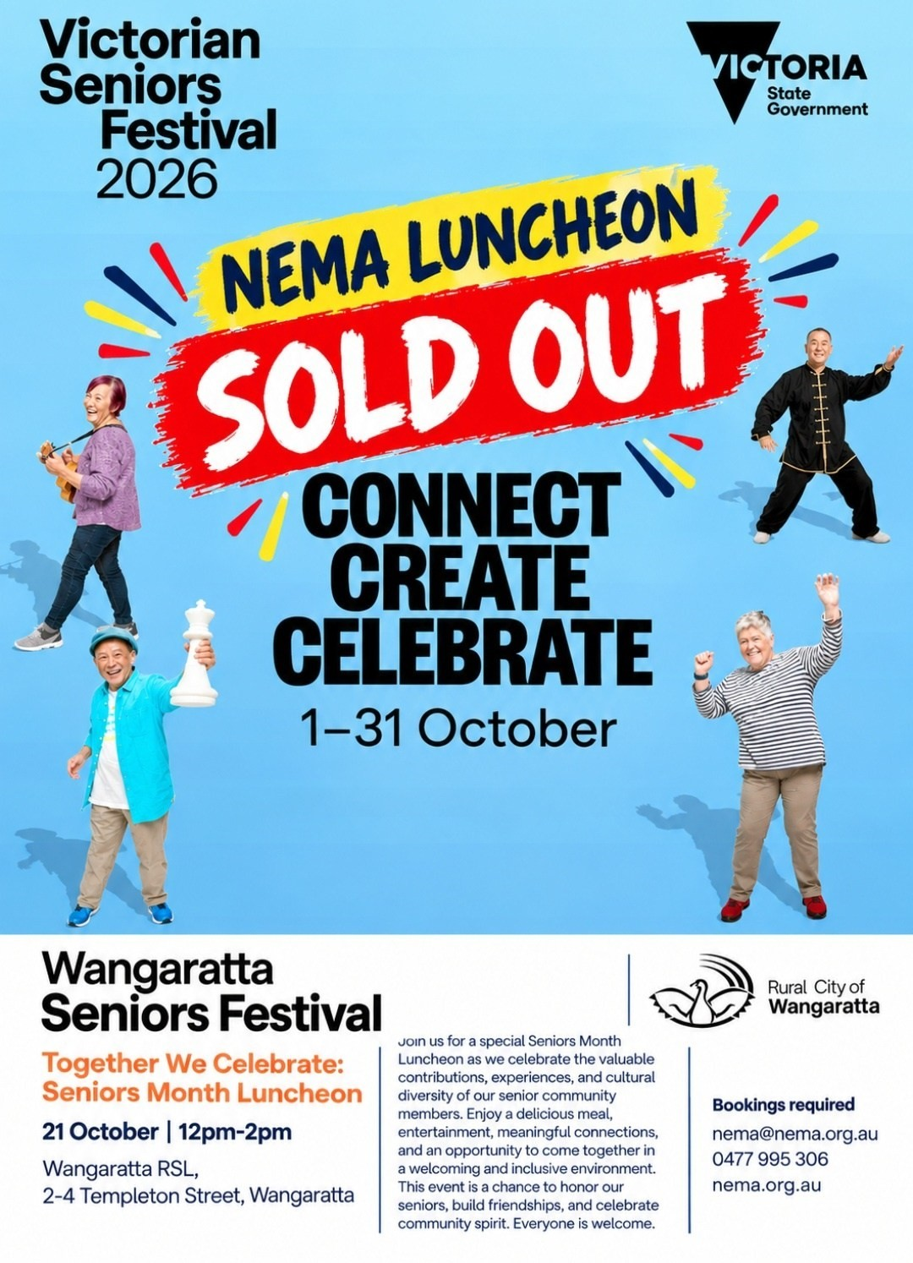
English Conversation Classes - Wangaratta & Benalla
Due to the school holidays our Conversational English Classes will take a short break and will resume Monday 5th October 2026. We look forward to welcoming everyone back!
Benalla English Conversation Classes
Tuesdays from 5:30pm to 7.00pm at Waminda Community House, 19 Ballintine St, Benalla Victoria 3672.
Wangaratta English Conversation Classes
Wednesdays from 6.00pm to 7.00pm at NEMA Office. Suite 4, 90 -100 Ovens St, Wangaratta VIC 3677.
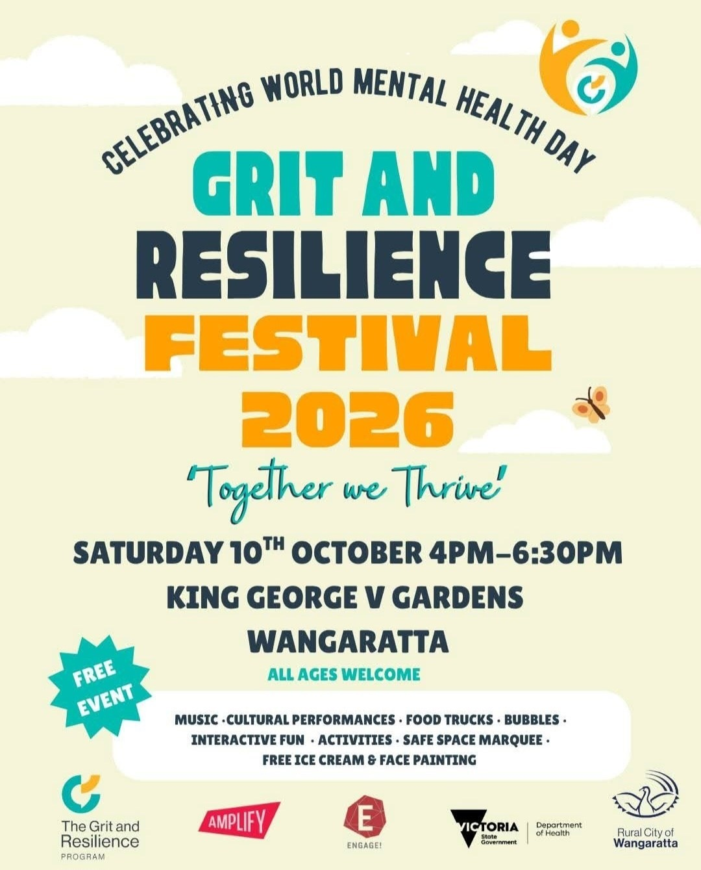
NEMA - Annual General Meeting
NEMA’s Annual General Meeting (AGM) will be held on:
Monday 26th October at 7.00pm, Suite 4, 90-100 Ovens St Wangaratta
Everyone is welcome. If you would like to vote, you will need to be a paid-up member by 30th September. If you simply wish to attend but not vote, you are also welcome. Reports and further information will be emailed in the coming weeks, including how you can vote if you are unable to attend.
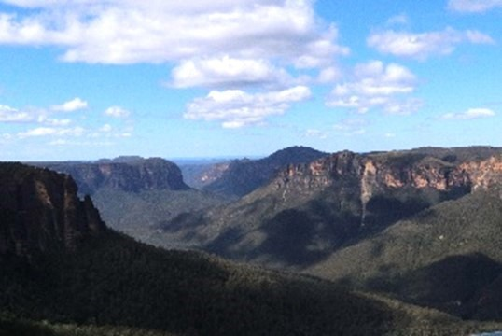
One significant item of business on the agenda concerns the revised Rules of NEMA (Constitution). This is an important matter and necessary for NEMA to be able to apply for DGR (Deductible Gift Recipient) status which has the potential to open additional funding.
We hope to see you there. Blue Mountain, NSW

Ian Prentice
President

MEMBERSHIP RENEWALS
NEMA wishes to advise that membership renewals are now due. We appreciate your support.
Thank you to those who have recently renewed their memberships.

  Happy Birthday to: Valmai, Gurpreet, Athmi, Marites,
  Pratibha, Joan, Krishna, Amelia, Shishir, Jantje, Shen,
  Neville, Vicky, Gemma, Steven, Yoshani, Angela, Mary,
  Veena, James, Suree, Jijin, Walter, Robin, Senaka,
  Renuka, Janvi, Marilyn, Adriene, Sebastiano, Penny,
  Narentheran, Assunta, Mal, Karen, Varun, Ian, Liza,
  Jenny, Lydia, Anju, Hassan, Lok, Anu, Gagandeep, Lin,
  Nance, Lesley, Margarita, Chela, Siew, Sheena, Ravi,
  Asmita

Happy Independence/National Day to our friends and members from Austria, China, Fiji, Germany, Spain, Taiwan, Hong Kong
 | 
  Welcome to our new members : Chandra (Rita), Neville, Julius, Angela and Lili

Wednesday 14th October : Alpine Social Group: 12.00pm. Lunch at the Ovens Hotel. 12.00 pm. Guest Speaker: Melanie Street at 1.15pm. Carpooling Meeting Points: Bright Croquet carpark—11.30am. Myrtleford Reject Shop carpark—11.40am. Wangaratta—meet at Ovens Hotel at 12.00pm.
Wednesday 21st October : Seniors Month Lunch. 12.00pm—2.00pm. RSL Wangaratta. 2-4 Templeton St. Wangaratta. Bookings are now closed.
Wednesday 21st October : Cultural Dinner 6.00pm—8.00pm. Purbrick Hall at Cathedral in Ovens St, Wangaratta. The country is Japan.
Monday 26th October: Annual General Meeting 7:00pm. Suite 4, 90-100 Ovens St., Wangaratta.


All weekly events for NEMA are free unless stated otherwise.

Tuesday: 5:30pm to 7.00pm Benalla English Conversation Classes at
Waminda Community House, 19 Ballintine St, Benalla.

Wednesday: 6.00pm —7.00pm Wangaratta English Lessons at our offices.

Alpine Shire Region: If anyone is interested in English lessons please contact the Office.
Contact details below. (Future lessons would be held in Bright)

I.T. Lessons by appointment only.
North East Multicultural Association
Suite 3, 90-100 Ovens St, Wangaratta 3677
Ph: 03 5721 5490 Mob: 0477 995 306

Office open Monday - Wednesday from 9:00am to 3:00pm.
Availability outside these hours by appointment only.

Calls to 0477 995 306 will be answered Mon - Thu 9:00am to 5:00pm. Any messages outside these hours will be returned next business day.
