
No. 6 2026
ATTENTION
MEMBERSHIP FEE INCREASE
We wish to advise that NEMA’s Annual Membership Fee has now been set at $20.00. This price increase was unanimously approved at NEMA’s Annual General Meeting in October 2025. NEMA membership entitles you to receive information regarding upcoming events as well as copies of our newsletter and general meeting minutes.
In serving and supporting multicultural community members across North East Victoria, NEMA offers you the opportunity to become a member and support multiculturalism in our community.
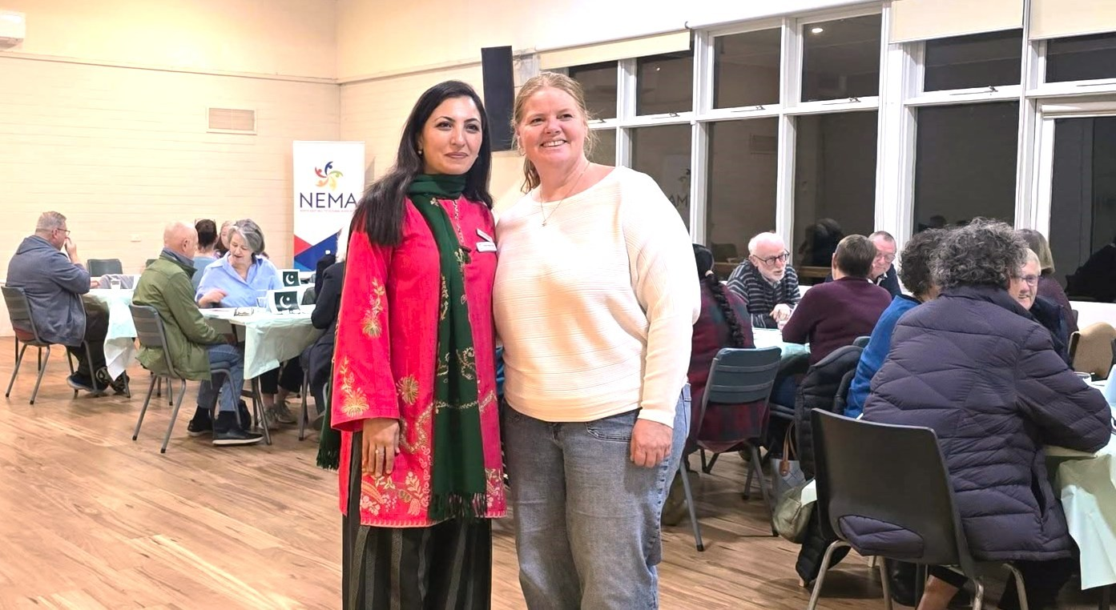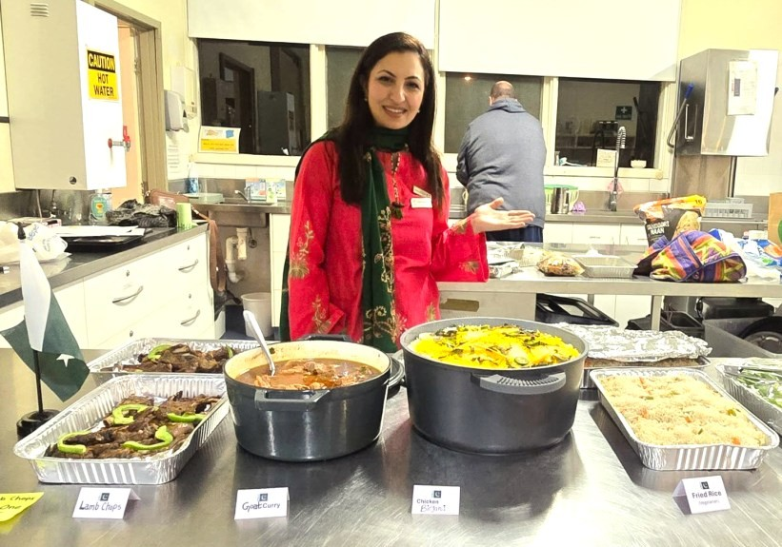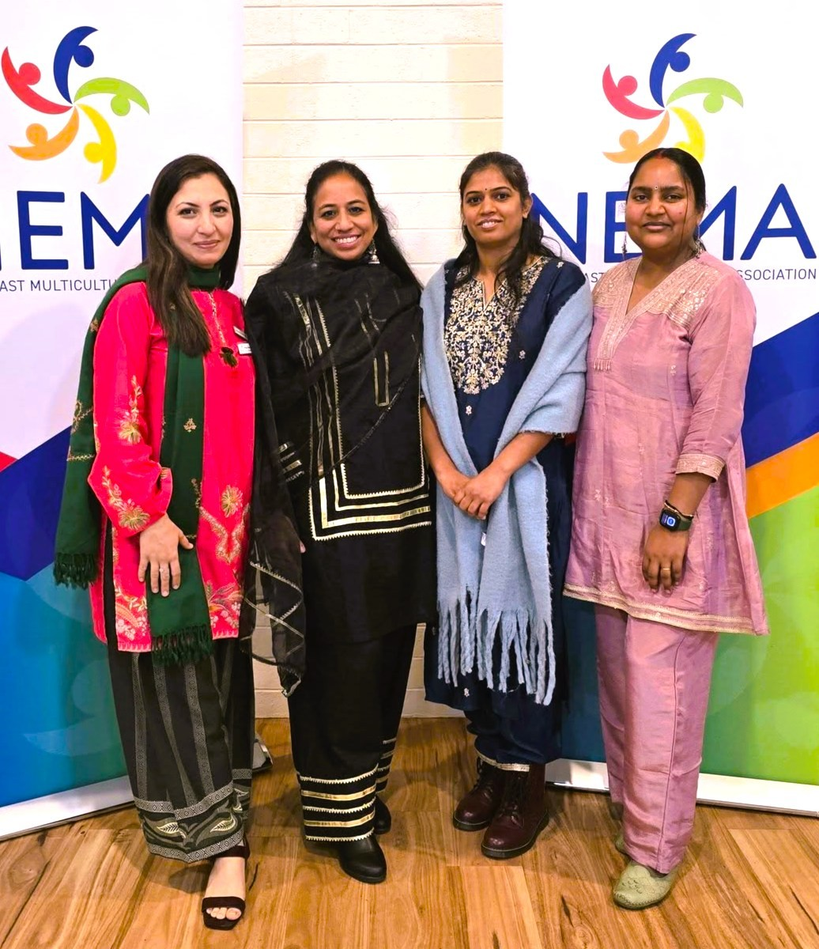

2026
Cultural Dinners

In partnership with Pangerang Community Hub, NEMA hosted
another wonderful Cultural Dinner, proudly funded by the Grit
and Resilience Program. Gathered together at Purbrick Hall,
some forty
-
five community members shared in the delights of
a delicious Pakistani Dinner lovingly prepared by NEMA
’
s own
Faryal Nawaz Khan.

Cultural Dinners are focused on bringing people together,
building connections and creating opportunities to learn about
and appreciate different cultures, traditions and values
through food. The sharing of meals creates a space for
conversation and understanding, providing a foundation for
developing a sense of belonging with the community. Thank you
to everyone attended and helped to make the evening so
meaningful.

Connecting Cultures Project
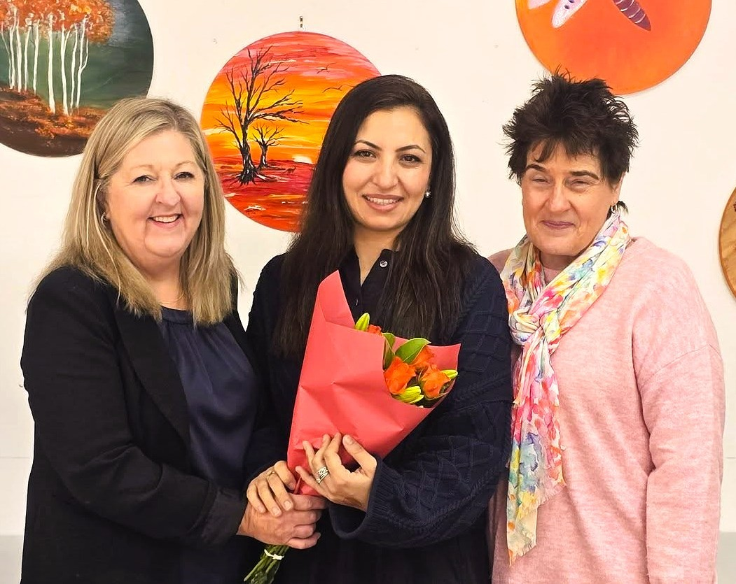
As the Connecting Cultures project draws to an end, NEMA proudly reflects on two years of building connections, celebrating diversity and strengthening community in Benalla. Through Free Driving Lessons, English Conversation Classes, Multicultural Morning Teas and community gatherings, as well as events such as Holi Festival/Colour Run, Harmony Day, Children’s Week and the Seniors Month Multicultural Tea, we have created spaces where people from all backgrounds could connect, learn and experience a sense of belonging. Our sincere thanks to Waminda
Community House for their valued partnership and ongoing support, along with our volunteers, service providers, partner organisations and the community members who made this journey possible. (At left: Waminda Community House Manager—Leeanne Bullard, and centre NEMA Community and Project Manager - Faryal Nawaz Khan).
Thank you, Penelope

NEMA would like to sincerely thank Penelope for her dedication and commitment to our Benalla English Classes over the past year. As a volunteer teacher, Penelope generously shared her time, knowledge and skills to support community members in improving their English, building confidence and strengthening their connections within the local community. Her patience, encouragement, and genuine care created a welcoming learning environment for students from diverse backgrounds.
We are incredibly grateful for the positive impact Penelope has made on both our students and the program. On behalf of NEMA and all the learners she has supported, we thank her for her valuable contribution and wish her all the very best for the future. Her efforts have helped make our community more connected, inclusive, and welcoming.

Refugee Week
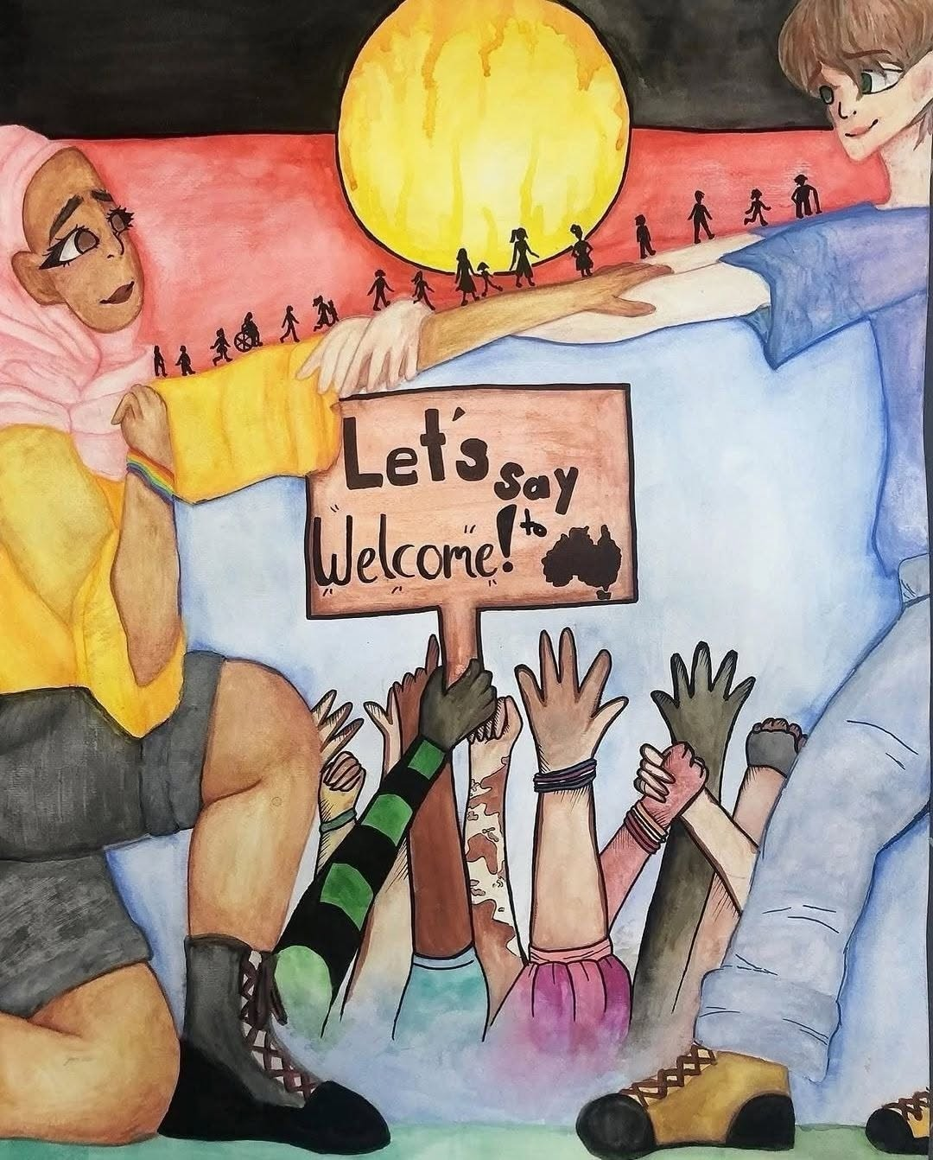
This Refugee Week, NEMA proudly acknowledges the strength, resilience and contributions of refugees in our community and across Australia. Refugee week is a time to celebrate the courage of people who have been forced to flee their homes in search of safety, hope and a better future. It is also an opportunity to reflect on the importance of compassion, inclusion and belonging.
At NEMA we are committed to supporting refugee and newly arrived families through settlement support, community connections and opportunities to thrive. We honour the diverse stories, cultures and experiences that enrich our region and strengthen our communities.
Together, let us continue to build a welcoming community where everyone feels valued, supported and empowered to belong.
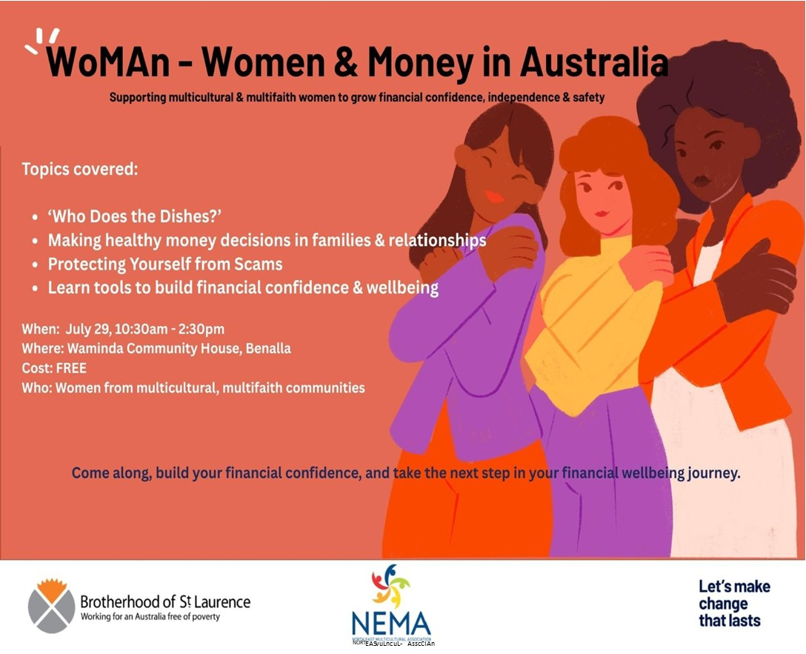

WoMAn
—
Women & Money in Australia

NEMA is pleased to invite women from multicultural communities to attend our upcoming Women and
Money Workshops in Benalla. The workshops will provide practical information and support around
budgeting, saving money, and financial wellbeing in a safe and welcoming environment.

Benalla workshop: Wednesday 29 July. 10:30am to 1:30pm at the Waminda Community House.

Mob. 0477 995 306

Bookings are
still available.

Limited seats
are available
and booking
is essential.

Light
refreshments
will be
provided.

CULTURAL DINNERS
6.00pm—8.00pm (The 3rd Wednesday of the month) New Location: Purbrick Hall
For Booking Contact: Pangerang Community Hub on 0357 213813 or NEMA on 0477 995 306
COST: $15 PER PERSON BOOKINGS ESSENTIAL AS PLACES ARE LIMITED
DATE COUNTRY
15th July Peru
19th August Germany
16th September The Philippines
21st October Japan
18th November Australia - Aussie BBQ
16th December Pot Luck Dinner - a shared celebration.
Bring a plate/dish from your own culture to share.
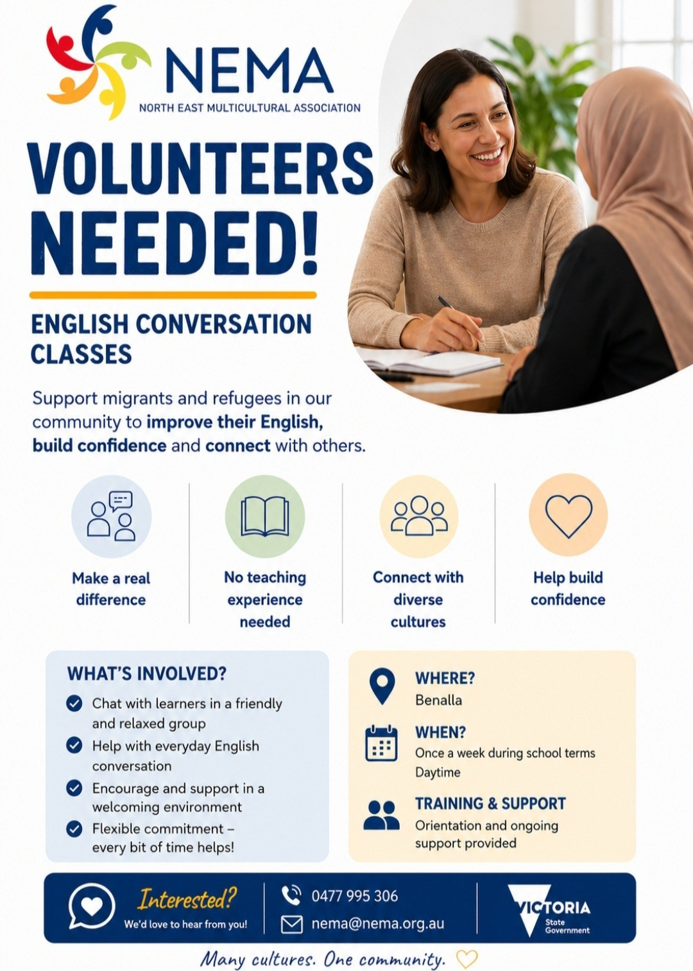
UPCOMING EVENT  NEMA will be hosting an information stall at the following Wangaratta event.  We look forward to connecting with community members and local service providers on the day.  HOMELESSNESS COMMUNITY CONNECTION DAY  AUGUST 5  10.00 am to 2.00 pm SALVATION ARMY 58 GRETA ROAD WANGARATTA |  |  | NOTICE  WANGARATTA ENGLISH LESSONS  School Holiday Break  Please be advised that  DUE TO TERM 2 SCHOOL HOLIDAYS  OUR WANGARATTA ENGLISH CLASSES  WILL NOT BE RUNNING  ON WEDNESDAY JULY 1 AND 8  WANGARATTA ENGLISH LESSONS  WILL RESUME ON WEDNESDAY JULY 15  FIRST WEDNESDAY OF TERM 3

  Happy Birthday to: Jenenne, Julius, Chawintee,
  Izzy, Saen, Ellie, Krishnathevi, Ramanpreet, Sita,
  Jean, Omeshvar, Dennis, Bernadette, Zeny, Usa,
  Karin, Firas, Josie, Upul, Brian, Manju, Rachelle,
  Thenmoli, Youssef, Peter, Jagdutt, Nawa, Sharon,
  Susan, Kate, Alfina, Coco, Tasfia, Deborah, Lucie,
  Vaibhav, Daham, Narinder, June, Bindu, Taylor,
  Jeremy, Vincy, Tanya and Narbada

Happy National/ Bastille, Independence Day to our friends and members from Canada,
Egypt, France, Maldives, Peru and USA
 | 
  Welcome to our new members: Mark, Adama and Paul
Thursday 2nd July : Savoy Ladies Social Group: 12.00 Noon. 43rd Birthday Lunch at Club Savoy, Myrtleford.
Wednesday 15th July : Midweek Break: 10.30am to 12.00pm. 90 -100 Ovens St, Wangaratta. Everyone welcome. Please bring a plate of food to share.
Wednesday 15th July : Cultural Dinner 6.00-8.00pm. Purbrick Hall at Cathedral in Ovens St, Wangaratta—Peru

Wednesday 22nd July : Bright Social Group: 12.00pm. Lunch at Alpine Hotel, Bright. Please contact Rita for further details.

All weekly events for NEMA are free unless stated otherwise.

Wednesday: 6.00pm —7.00pm Wangaratta English Lessons at our offices.
(ENGLISH LESSONS WILL NOT BE RUNNING ON JULY 1 AND 8—PLEASE SEE NOTICE ON PAGE 5)

Alpine Shire Region: If anyone is interested in English lessons please contact the Office.
Contact details below. (Future lessons would be held in Bright)

I.T. Lessons by appointment only.

North East Multicultural Association
Suite 3, 90-100 Ovens St, Wangaratta 3677
Ph: 03 5721 5490 Mob: 0477 995 306

Office open Monday - Wednesday from 9:00am to 3:00pm.
Availability outside these hours by appointment only.
Calls to 0477 995 306 will be answered Mon - Thu 9:00am to 5:00pm.
Any messages outside these hours will be returned next business day.

If you need help with education, advocacy or just feel like a ‘cuppa’ and a chat, call in and see one of our friendly volunteers.
