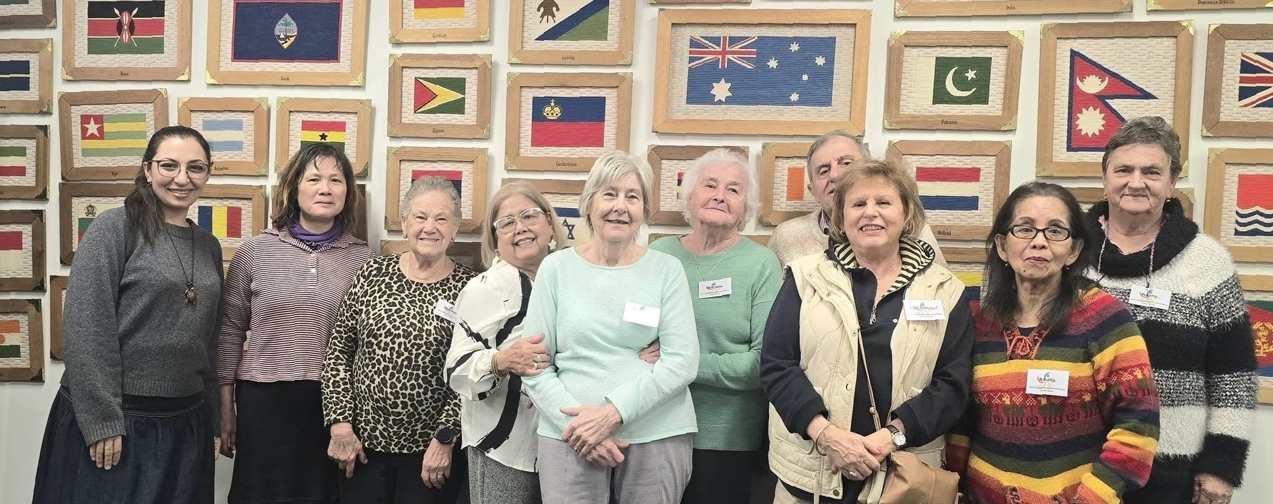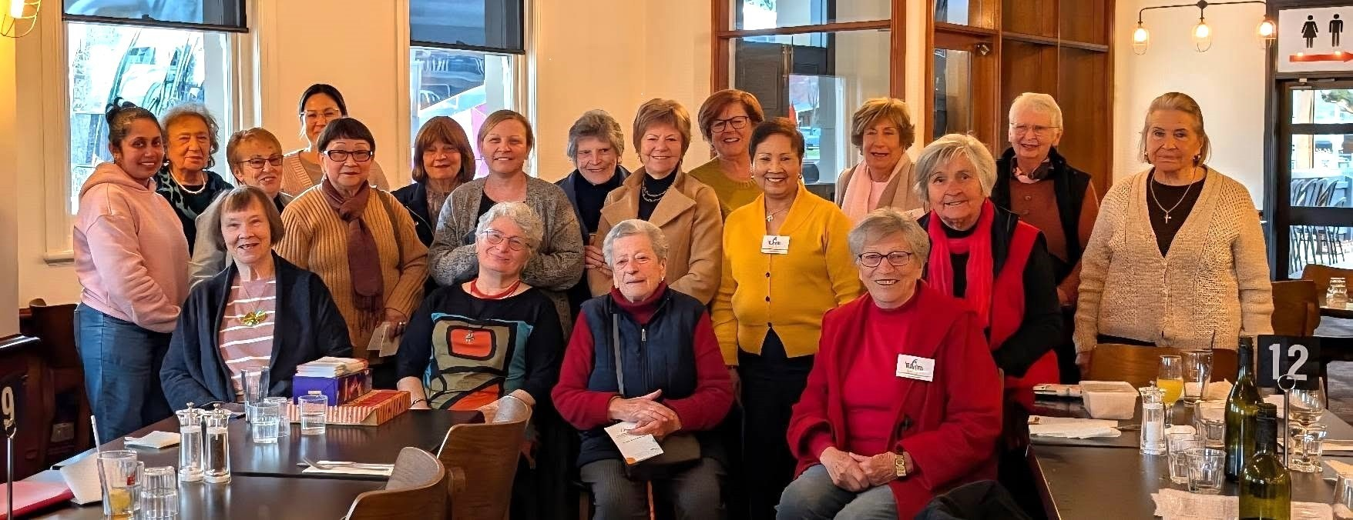
No. 8
—

2026

NEMA
’
S SOCIAL GROUPS

NEMA
’
s Alpine (formerly Bright) and Wangaratta Social Groups meet monthly, providing members with a
welcoming space to connect, socialise and share information. (
For details of forthcoming outings, please
turn to the last page of our newsletter.)

In August, Vanida and Kristy from
Gateway Healt
h

joined our Alpine Social Group and spoke about mental
health, wellbeing and available support services. They engaged warmly with members, answered
questions and shared useful information about staying connected and looking after our wellbeing. These
regular social gatherings continue to strengthen community connections, reduce social isolation and
provide opportunities for members to access useful information and support in a relaxed and culturally
inclusive environment. Everyone is welcome. For further information, please contact the office.

Below top:
Alpine Social Group members enjoy their August gathering at La Coppa, Myrtleford.

Below bottom:
NEMA
’
s August Midweek Break. L
-
R Faryal, Su, Evangelina, Zeny, Dieny, Marijana, Seb,
Irene, Amelia and Hanny.

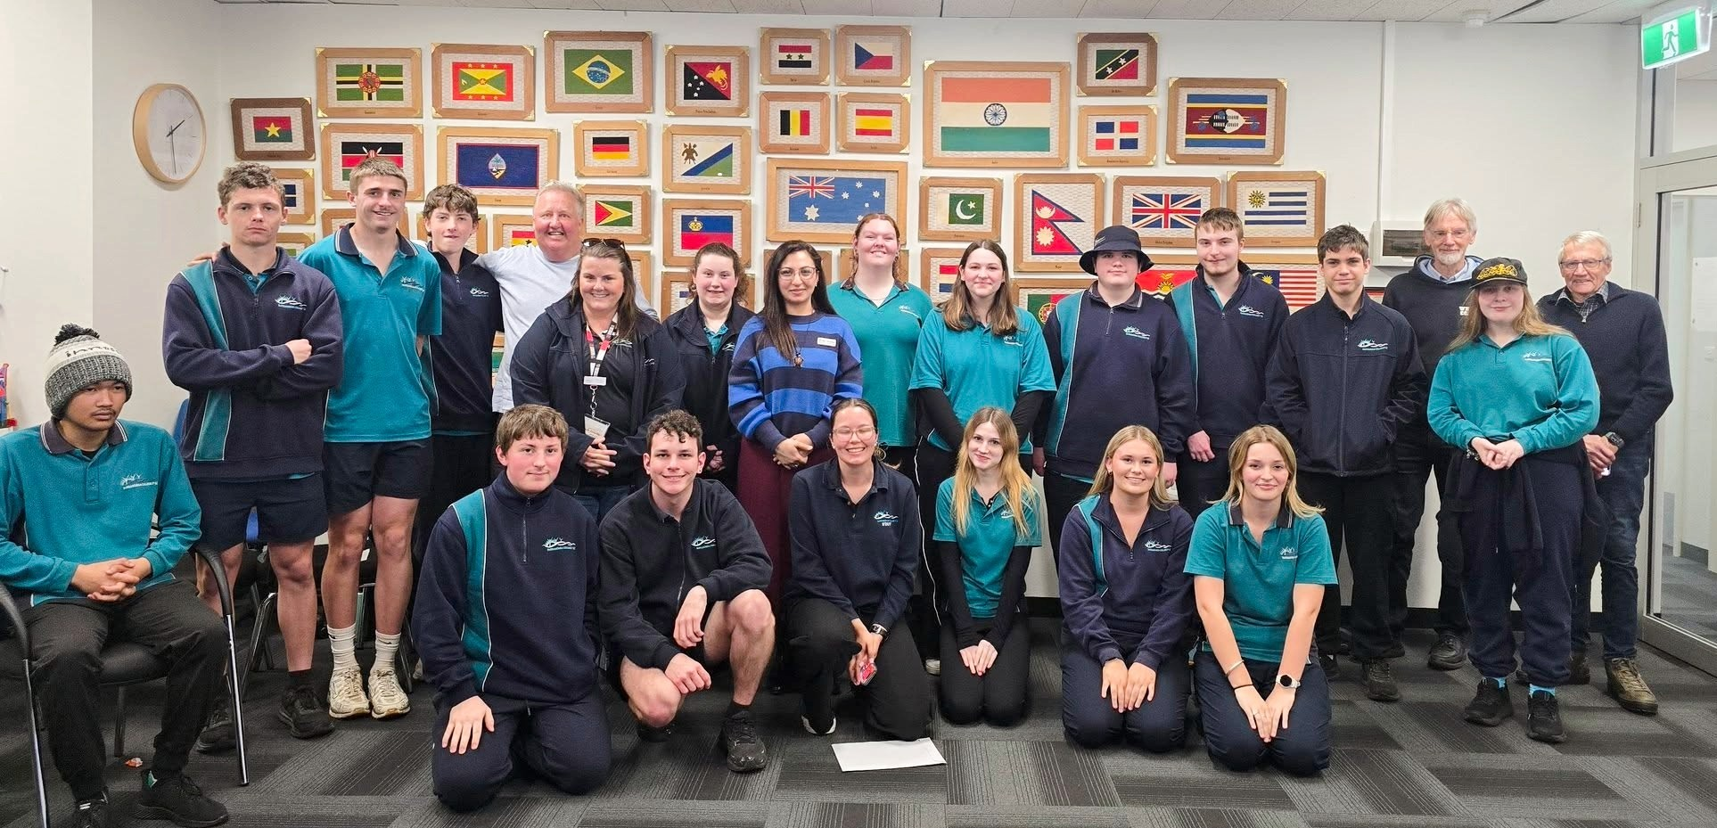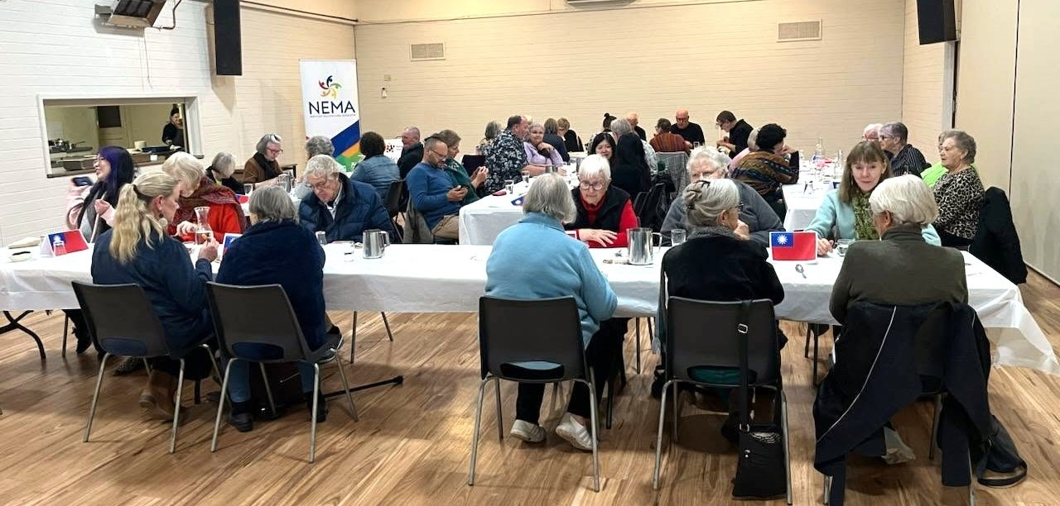

YARRAWONGA COLLEGE P
-
12
STUDENTS VISIT NEMA

We were pleased to welcome Yarrawonga P
–
12

students to the NEMA office following the completion of
their Personal Development course.

Students explored what community means, migration, refugee and asylum seeker experiences, the
challenges faced by CALD communities, and the valuable contributions multicultural communities make
to Australia. We also looked at relevant data and shared lived experiences to build greater understanding
and awareness.

To finish the
session, students
participated in
our
“
Web of
Strings
-

We Are
All Connected
”
activity. The
activity
demonstrated
how every
person has an
important role in
the community
and how our
different cultures, experiences and backgrounds are connected. It highlighted the importance of
inclusion, belonging, trust, communication, respect and mutual support in building strong and connected
communities.

Diversity makes our communities stronger
-

and we are all connected.

TAIWAN CULTURAL DINNER

Thank you to all our community members, volunteers and supporters who joined us and helped make the
evening so special.

A huge thank you to Enros for being such a wonderful ambassador for Taiwanese culture and for
preparing and sharing such delicious food with our community. We are also incredibly grateful to our
partner organisation,
Pangerang Community Hu
b
,
for the wonderful partnership and ongoing support
that helps make our Cultural Dinners a success. A special thank you to the Grit and Resilience Program for
the funding support that made this event possible.

Save the date! Our next
Cultural Dinner will be held on
17
September. We look
forward to bringing everyone
together again to enjoy
another evening of delicious
food, culture and community
connection!

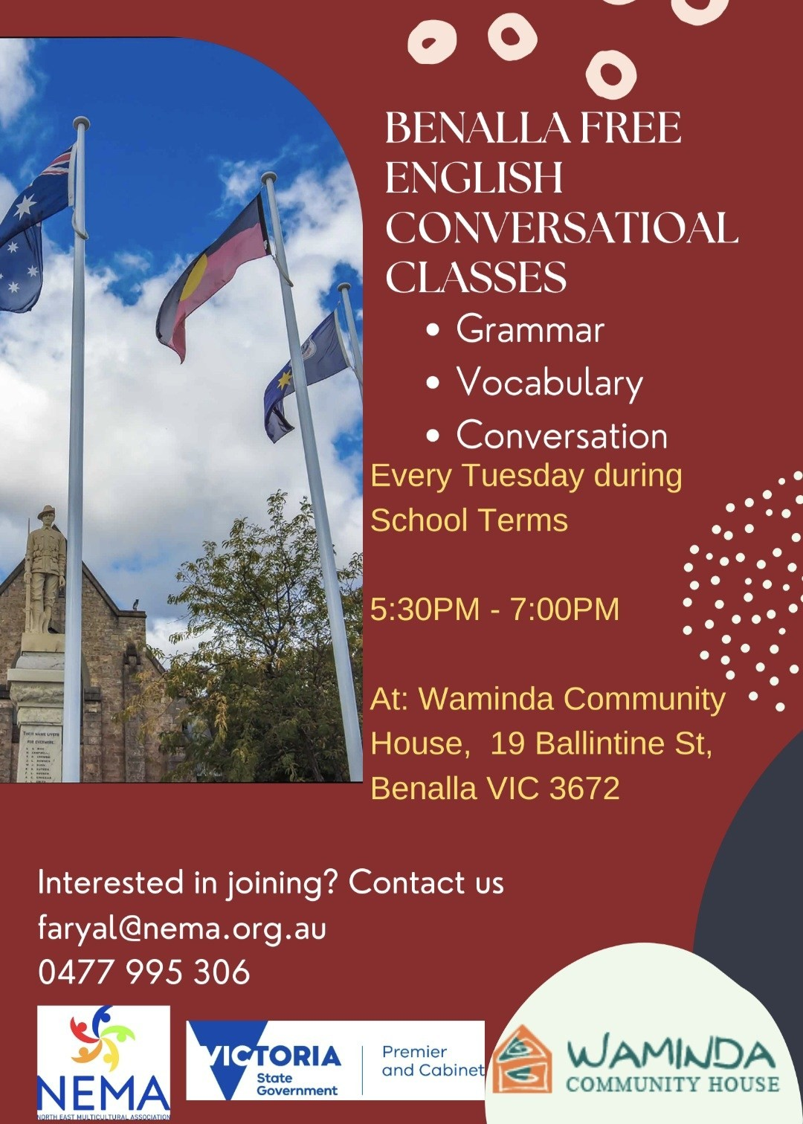
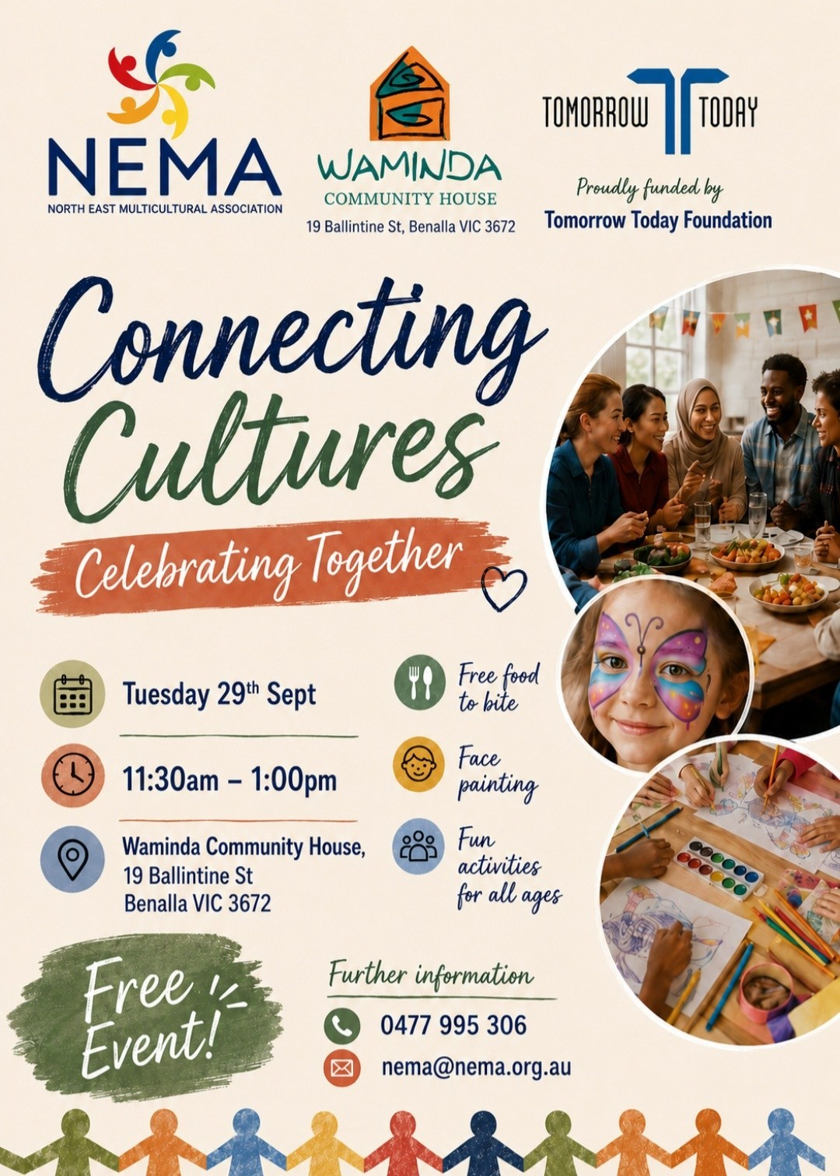

2026 CULTURAL DINNERS
6.00pm—8.00pm (The 3rd Wednesday of the month) New Location: Purbrick Hall
For Booking Contact: Pangerang Community Hub on 0357 213813 or NEMA on 0477 995 306
COST: $15 PER PERSON - BOOKINGS ESSENTIAL AS PLACES ARE LIMITED
16th September - The Philippines
21st October - Japan
18th November - Australia - Aussie BBQ
16th December - Pot Luck Dinner: a shared celebration.
Bring a plate/dish from your own culture to share.
NB: Details of the specific cultural food to be prepared on the night will be provided ahead of each month.

GROWING TOGETHER
Welcome to our new members : Rhee, Laxmi, Lee and Stella
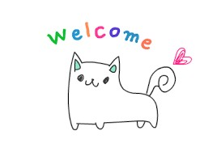
Our Bright Social Group is continuing to grow into a vibrant and diverse community. With the group expanding and welcoming people from across the Alpine area, the NEMA Board has decided to rename the Bright Social Group to the Alpine Social Group.
The new name better reflects the diverse community we bring together and our growing connections across the Alpine region.

  Happy Birthday to: Lisa, Kevin, Robert, Joy, Kimberley,
  Felicity, Katriona, Joyce, Truus, Gitendra, Pasan, Johnny,
  Manjinderpal, Charlene, Tracy, Patrick, Riccardo, Jan, Hongyin,
  Floren, Fish, Sufyan, Rama, Adelle, Pisollaya, Daniel, Madhura,
  Gagandeep, Channa, Evelyn, Durga, Francesco, Ariba, Farah,
  Pechy, Sirjan, John, Henk, Gleen, Sushma, Leonilda, Delia,
  Anecia, Liezl, Sharanjit, Mary, Chainarong, Joe, Sam, Margarette
Happy Independence/National Day to our friends and members from India, Indonesia, Malayasia, Pakistan, Singapore and Ukraine

Thursday 10th September : Savoy Ladies Social Group: 12.00pm. Lunch at Club Savoy, Myrtleford.
Wednesday 16th September : Midweek Break: 10.30am to 12.00pm. 90 -100 Ovens St, Wangaratta. Everyone welcome! Please bring a plate of food to share.
Wednesday 16th September : Cultural Dinner 6.00-8.00pm. Purbrick Hall at the Cathedral in Ovens St, Wangaratta. The Philippines. Please see our Facebook Page for updates or phone the NEMA Office.
Wednesday 23rd September : Alpine Social Group: 12.00pm. Lunch at Red Stag Deer Farm, Myrtleford. Bright people, meet at Bright Croquet Car Park for car pooling at 11.20am. Myrtleford and Wangaratta people, meet at Red Stag Deer Farm at 12.00pm. Contact Rita for further details.



All weekly events for NEMA are free unless stated otherwise.

Tuesday: 5.30pm —7.00pm Benalla Conversational English Classes at Waminda Community House. Wednesday: 6.00pm —7.00pm Wangaratta English Lessons at our offices.

Alpine Shire Region: If anyone is interested in English lessons please contact the Office.
Contact details below. (Future lessons would be held in Bright)

I.T. Lessons by appointment only.
North East Multicultural Association
Suite 3, 90-100 Ovens St, Wangaratta 3677
Ph: 03 5721 5490 Mob: 0477 995 306

Office open Monday - Wednesday from 9:00am to 3:00pm.
Availability outside these hours by appointment only.

Calls to 0477 995 306 will be answered Mon - Thu 9:00am to 5:00pm.
Any messages outside these hours will be returned next business day.

If you need help with education, advocacy or just feel like a ‘cuppa’ and a chat, call in and see one of our friendly volunteers. 